`

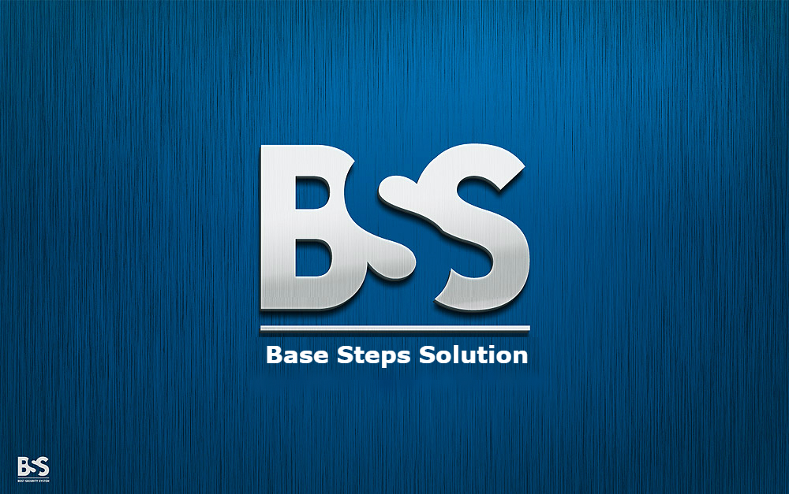

Meeting Minutes

Van Lang Admissions

# Revision Table

|  |  |  |  |
| --- | --- | --- | --- |
| Author | Date | Reason for changes | Version |
| Khoi Nguyen | 10/10/2016 | Initial Document | 1.0 |

Table of Contents

Revision Table 1

1 Purpose of meeting: 3

2 Participants in meeting 3

3 Content 3

4 References 4

5 Note 4

6 To Do Tasks 4

7 Next meeting 4

|  |  |  |  |  |  |
| --- | --- | --- | --- | --- | --- |
| **Writer:** | Nguyễn Anh Khởi | **Location:** | Room 706A | | |
| **Date:** | **10/10/2016** | **Start:** | 10h45 | **Finish:** | 12h15 |

|  |
| --- |
| Purpose of meeting: |
| * Discuss about Capstone Project * Discuss about Team SWOT , Technology SWOT , Individual SWOT |

|  |  |  |  |
| --- | --- | --- | --- |
| Participants in meeting | | | |
| Name | Role | E-mail | Phone |
| Lê Sĩ Phú | Mentor | lesiphu@vanlanguni.vn | 0986982003 |
| Nguyễn Thái Hiền | Leader | hiennguyenthai93@gmail.com | 0937398353 |
| Trần Xuân Hải | Member | haitran2402@gmail.com | 01662542331 |
| Nguyễn Anh Khởi | Member | nguyenanhkhoicntt@gmai.com | 0933408603 |
| Đoàn Anh Minh | Member | minhdoan414@gmail.com | 01284144641 |
| Nguyễn Hoàng Anh Tài | Member | nguyenhoanganhtai95@gmail.com | 01203244599 |
| Nguyễn Xuân Thái Hiền | Member | bs.gtts44@gmail.com | 0974949241 |

|  |
| --- |
| Content |
| - Introduce Team.  - Introduce Team Objective.  - Introduce Team Rule.  - Mentor introduce the purpose of Capstone Project  - Mentor suggest that who absence 3 times will be quit the Capstone project  - Mentor instructions on how to work.  - Mentor suggestions on how to write document.  - Mentor instructions on how to work breakdown.  - Mentor instructions on how to choose the process : recommended : Incremental process  - Agreement on the weekly meeting schedule : Every Monday. Send all meeting’s documents every Thursday.  - Agreement on the document was written in English.  - Discuss about System context.  - Ask about software development ( Use What ? How to use? How to connect SQL ? Use what to repository … ) : Recommended :  Nodejs : Research , learn in 1-2 weeks  Meteor : Research in Internet  - Discuss about Team SWOT , Technology SWOT , Individual SWOT : SWOT will not evaluate the objective reasons |

|  |
| --- |
| References |
|  |

|  |
| --- |
| Note |
| Next week : Topic decision |

|  |  |  |  |  |
| --- | --- | --- | --- | --- |
| To Do Tasks | | | | |
| **#** | **Task** | **Start date** | **Completion date** | **Status** |
| 1 | Write Master Plan | 10/10/2016 | 17/10/2016 | High |
| 2 | Learn software development ( Nodejs , Meteor, … ) | 10/10/2016 | 17/10/2016 | Medium |

|  |  |  |  |
| --- | --- | --- | --- |
| Next meeting | | | |
| **Date: 17/10/2016** | **Content:** | **Time: 10h45** | **Location: Room 706A** |
| **Writer:** | Nguyễn Anh Khởi | | |

---- *** ----